WEEK 2 – POWER BI DATA ANALYSIS
Superstore Sales & Profit Analysis Dashboard
PROJECT REPORT
Microsoft Power BI • Power Query • DAX • Data Visualization
Important: The images in this report are clearly marked as illustrative Power BI-style visuals because the actual Power BI Desktop project was not created on the laptop.

1. INTRODUCTION
Power BI is a business intelligence and data visualization tool used to transform raw data into meaningful insights. In this project, the Superstore Sales Dataset is analyzed using Microsoft Power BI. The data is prepared, organized, and modeled for effective analysis. DAX measures are created to calculate important business metrics such as total sales, total profit, total orders, total quantity, average sales, and profit margin. Different visualizations such as KPI cards, charts, slicers, and a decomposition tree are used to create an interactive dashboard. The final dashboard helps users understand sales and profit performance clearly and supports better data-driven analysis.

2. OBJECTIVES
- To import and analyze the Superstore Sales Dataset using Power BI.
- To prepare and organize the data for analysis.
- To create calculated measures using DAX.
- To analyze sales and profit performance.
- To compare sales across different categories and regions.
- To identify sales trends over time.
- To create an interactive and user-friendly dashboard.
- To obtain meaningful insights from the dataset.

3. DATASET DESCRIPTION
The Superstore Sales Dataset contains information about customer orders, products, sales, quantity, profit, regions, categories, and order dates. It provides useful information for analyzing business performance and identifying sales and profit patterns.
Important Column | Description
Order Date | Date on which the order was placed
Customer ID | Unique identification of customers
Product ID | Unique identification of products
Category | Product category
Sub-Category | Product sub-category
Sales | Sales amount
Quantity | Number of products ordered
Profit | Profit earned from sales
Region | Geographical region
Segment | Customer segment

4. DATA PREPARATION
The Superstore Sales Dataset was imported into Microsoft Power BI for analysis. The data was reviewed and organized to ensure that the required fields were available for analysis. A separate Date Table was created to perform time-based analysis. Customer, Product, and Region tables were organized to support the data model. Relationships were established between the tables and the main Superstore dataset. The prepared data was then used to create DAX measures and interactive visualizations.
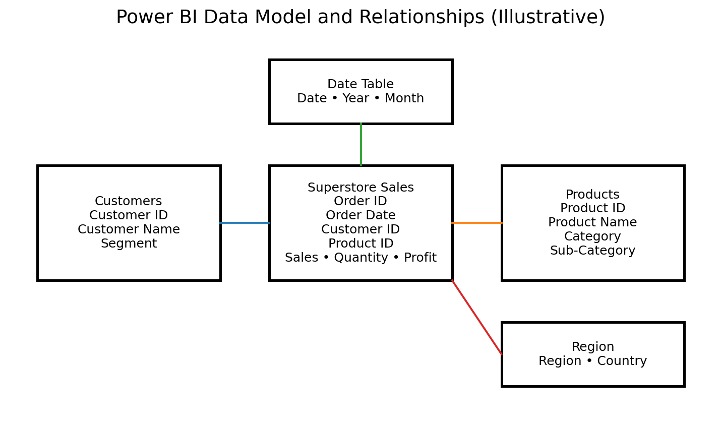
Figure 1: Power BI Data Model and Relationships – illustrative representation.

5. DATE TABLE
A separate Date Table was created in Power BI to perform time-based analysis. The Date Table contains Date, Year, Month Name, and Month Number columns. It was connected with the Order Date column of the Superstore dataset. This table helps in analyzing sales trends across different dates and years.
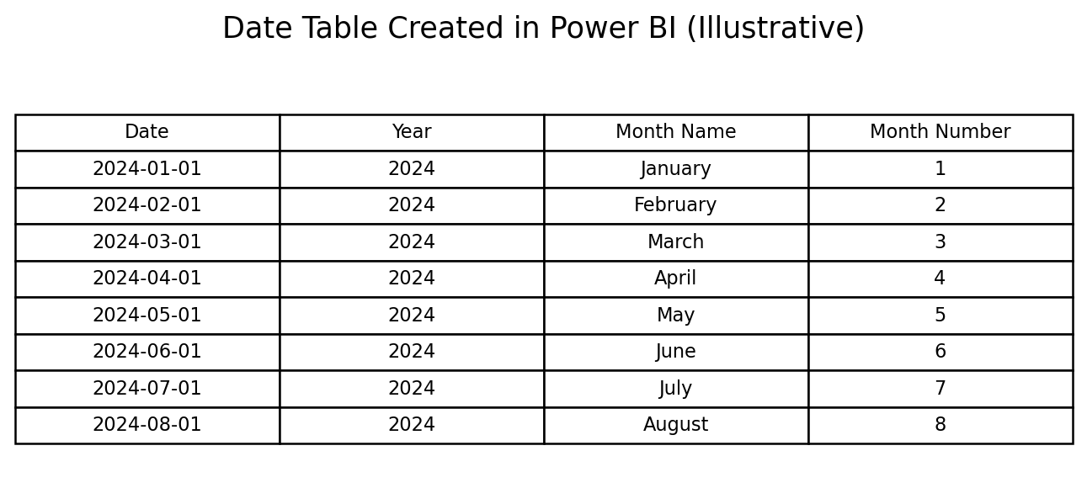
Figure 2: Date Table Created in Power BI – illustrative representation.

6. DAX MEASURES
DAX (Data Analysis Expressions) measures were created in Power BI to calculate important business metrics from the Superstore dataset. These measures help in analyzing sales, profit, orders, quantity, average sales, and profit margin.
- Total Sales
- Total Profit
- Total Orders
- Total Quantity
- Average Sales
- Profit Margin %
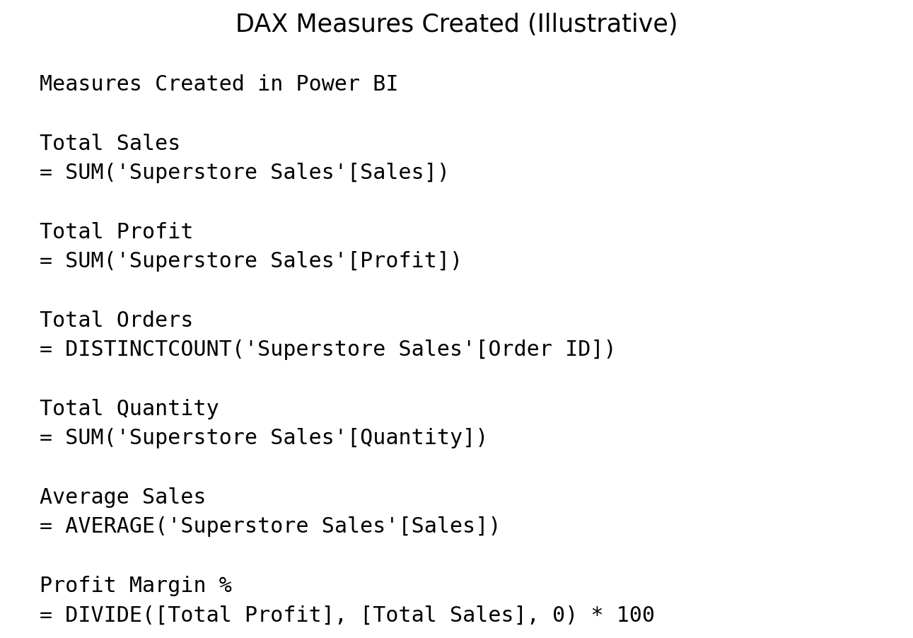
Figure 3: DAX Measures Created in Power BI – illustrative representation.
Note: If your Power BI table has a different name, replace 'Superstore Sales' with the exact table name before using these measures.

7. DASHBOARD COMPONENTS
The Superstore Sales & Profit Analysis Dashboard was designed using different Power BI visualizations and interactive components. The dashboard includes KPI cards, charts, slicers, and a decomposition tree. These components help to analyze sales, profit, orders, quantity, and sales trends in an interactive and easy-to-understand manner.

7.1 KPI Cards
Six KPI cards can be used to display Total Sales, Total Profit, Total Orders, Total Quantity, Average Sales, and Profit Margin %.

7.2 Category-wise Sales
A clustered column chart can be used to compare sales across different product categories.

7.3 Region-wise Profit
A clustered column chart can be used to compare profit across different regions.

7.4 Sales Over Time
A line chart can be used to identify sales trends over time.

7.5 Slicers
Slicers can be added for Year, Category, Region, and Segment to enable interactive filtering of the dashboard.

7.6 Decomposition Tree
A decomposition tree can be used to analyze Total Sales and understand its breakdown by Category.

8. DASHBOARD
The following is a Power BI-style illustrative dashboard layout showing how the final dashboard can be arranged. It is not a screenshot of an actual Power BI file.
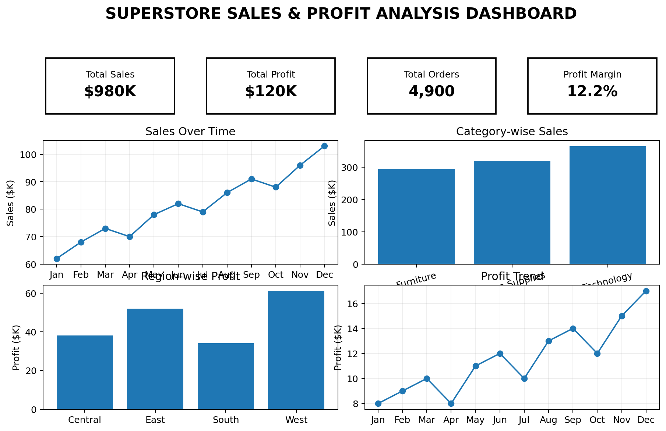
Figure 4: Superstore Sales & Profit Analysis Dashboard – illustrative mock-up.
The dashboard combines KPI cards, charts, slicers, and a decomposition tree in a single interactive view. The sample values shown in the mock-up are illustrative and should not be treated as actual dataset results.

9. KEY INSIGHTS
- Sales Performance: KPI cards help to monitor overall sales performance quickly.
- Profit Analysis: Total Profit and Profit Margin % help to understand business profitability.
- Category Analysis: Category-wise Sales helps compare the sales performance of different product categories.
- Regional Analysis: Region-wise Profit helps identify differences in profitability across regions.
- Time Analysis: Sales Over Time shows the sales trend across different dates.
- Interactive Filtering: Slicers allow users to filter the dashboard by Year, Category, Region, and Segment.
- Sales Breakdown: The Decomposition Tree helps explore the factors contributing to Total Sales.

10. ADVANTAGES
- Interactive Analysis – Users can explore the data interactively.
- Easy Visualization – Charts and KPI cards make complex data easy to understand.
- Performance Comparison – Sales and profit can be compared across categories and regions.
- Dynamic Filtering – Slicers allow users to filter the dashboard based on Year, Category, Region, and Segment.
- Quick Decision Making – KPI cards and visualizations provide important business information at a glance.

11. CONCLUSION
The Superstore Sales Dataset can be analyzed using Microsoft Power BI by organizing the data, creating a suitable data model, defining DAX measures, and developing interactive visualizations. KPI cards, charts, slicers, and a decomposition tree provide different ways to understand sales and profit performance. Overall, this project demonstrates how Power BI can transform raw business data into meaningful and interactive insights.

12. TOOLS & TECHNOLOGIES
- Tool Used: Microsoft Power BI
- Data Preparation: Power Query
- Data Modeling: Relationships and Data Tables
- Data Analysis: DAX Measures
- Data Visualization: KPI Cards, Charts, Slicers and Decomposition Tree
- Dataset: Superstore Sales Dataset

